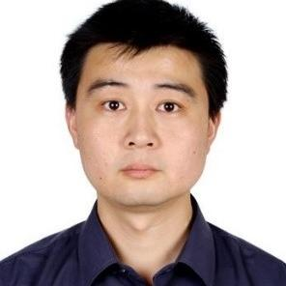

Jian Fu
Wuhan University of Technology， Deputy Head of Automation DepartmentResearch Interests:Artificial intelligence , Human robot collaboration
Follow me: 中文

HomePage
Congratulation
Jian Fu receives CNSF grant (general program) titled as "study on motor skill acquistion
and execution for the coordination of human-robot collaboration".
Congratulation
Sun Junwei, 2017 graduate student, received an offer from jingdong research and development in shenzhen
Wang Kaiyuan, 2017 graduate student, received an offer from HIK VISION in Nanjing
Li Yuanyuan, 2017 graduate student, received an offer from WINGTECH in Shanghai
Du Yucheng, 2017 graduate student, received an offer from electric of ShangNeng in Wuxi
Chen Siming, 2017 graduate student, received an offer from iFLYTEK in Wuhan
Congratulation
The paper of Chen Siming,VariousRobot Motor Skills Learning with PI2-GMR ,is include in IEEE
The paper of Wei Da,AnImproved LWR Based Forcing Term Learning from DMPs ,is include in IEEE
The paper of Sun Junwei,SPARK– A Big Data Processing Platform for Machine Learning,is include in IEEE
The paper of Wang Kaiyuan,AMethod of SIFT Simplifying and Matching Algorithm Improvement ,is include in IEEE

Publications
- A Method of SIFT Simplifying and Matching Algorithm Improvement
Xinmin Zhou;Kaiyuan Wang;Jian Fu. Industrial Informatics - Computing Technology, Intelligent Technology, Industrial Information Integration (ICIICII), 2016 International Conference on: 19 January 2017 Abstract
- SPARK – A Big Data Processing Platform for Machine Learning
Jian Fu;Junwei Sun;Kaiyuan Wang. Industrial Informatics - Computing Technology, Intelligent Technology, Industrial Information Integration (ICIICII), 2016 International Conference on 10.1109/ICIICII.2016.0023: 19 January 2017 Abstract
- An Improved LWR Based Forcing Term Learning from DMPs
Jian Fu; Da Wei. Industrial Informatics - Computing Technology, Intelligent Technology, Industrial Information Integration (ICIICII), 2016 International Conference on: 19 January 2017 Abstract
- Various Robot Motor Skills Learning with PI2-GMR
Jian Fu；Siming Chen. Industrial Informatics - Computing Technology, Intelligent Technology, Industrial Information Integration (ICIICII), 2016 International Conference on: 19 January 2017 Abstract
- A hybrid evolving and gradient strategy for approximating policy evaluation on online critic-actor learning
Jian Fu; Haibo He; Huiying LI; Qing Liu. Lecture Notes in Computer Science (including subseries Lecture Notes in Artificial Intelligence and Lecture Notes in Bioinformatics): 2012 ,vol 7367 ,p 555-564 Abstract
- Adaptive Learning and Control for MIMO System Based on Adaptive Dynamic Programming
Jian Fu; Haibo He; Xinmin Zhou. Neural Networks, IEEE Transactions on: 16 June 2011 ,vol.22, no.7, ,pp.1133-1148 Abstract
- Adaptive dynamic programming with balanced weights seeking strategy
Jian Fu; Haibo He; Zhen Ni. Adaptive Dynamic Programming And Reinforcement Learning (ADPRL), 2011 IEEE Symposium on: 29 July 2011Abstract
- A Novel DS-GMR Coupled Primitive for Robotic Motion Skill Learning
Fu, Jian; Ning, Li; Wei, Sujuan; Zhang, Liyan. Industrial Informatics - Computing Technology, Intelligent Technology, Industrial Information Integration (ICIICII), 2015 International Conference on: 3-4 Dec. 2015 ,111-115 Abstract
- Online learning control based on projected gradient temporal difference and advanced heuristic dynamic programming
Jian Fu; Sujuan Wei; Haibo He; Shengyong Wang. Neural Networks (IJCNN), 2014 International Joint Conference on: 2014/7 ,vol. 6 no.11,3649-3656 Abstract
- 一种基于扩展有限状态机的业务流程管理的建模方法
傅剑;马冰洁;熊沁怡;卫素娟;张俊. 专利: 2015-08-26 Abstract

Team Members
Master:
2017:
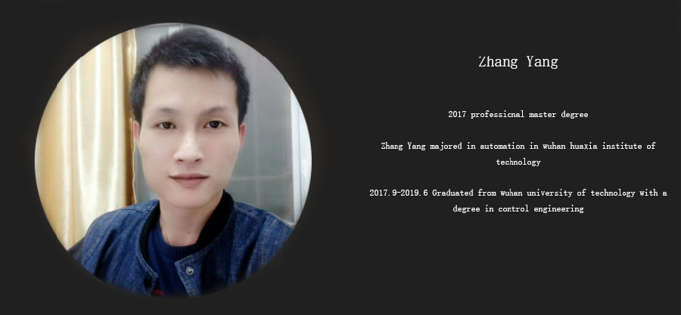
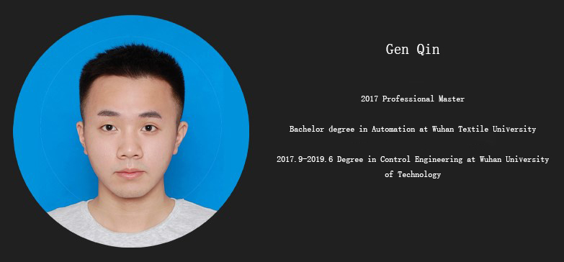
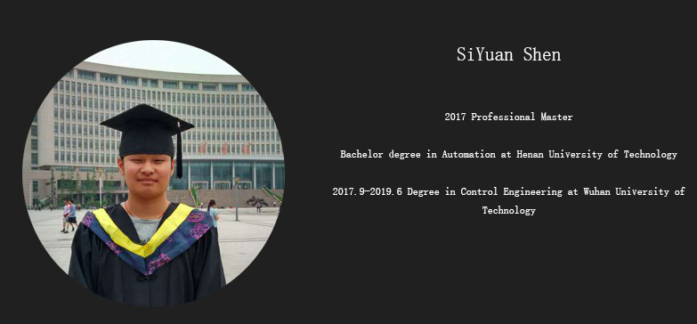
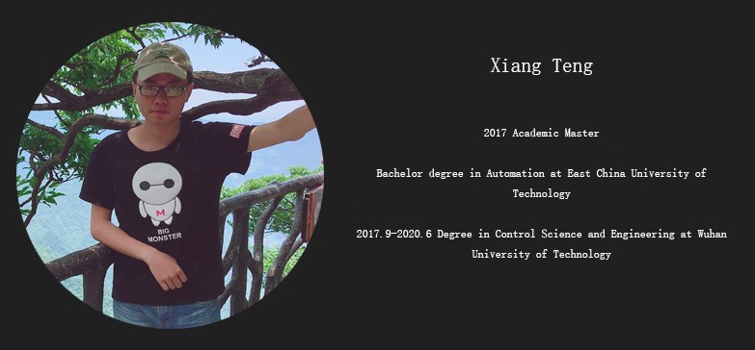
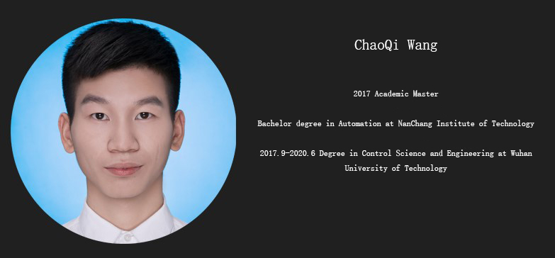
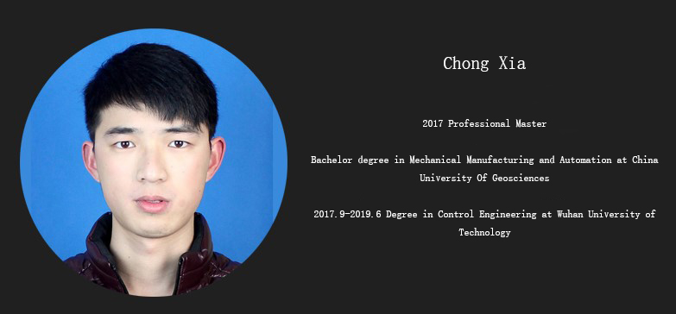
2016:
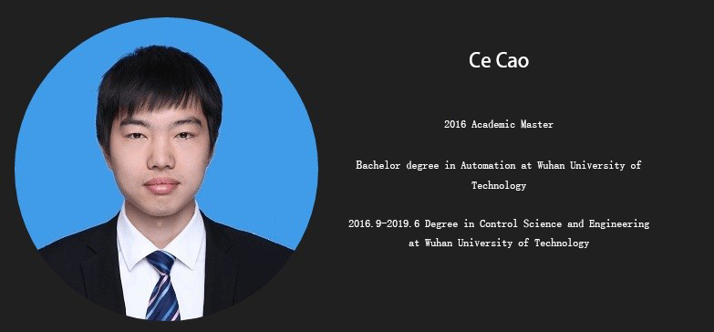
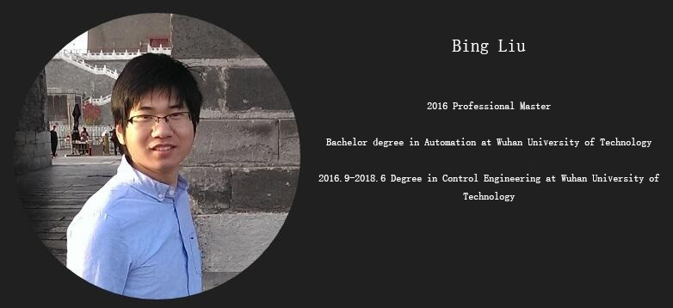
2015:
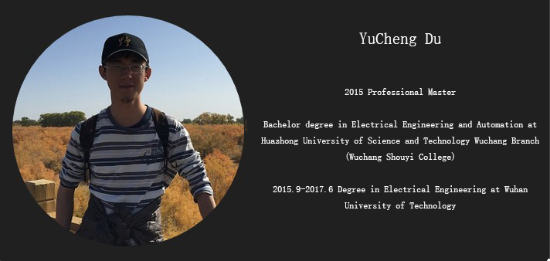
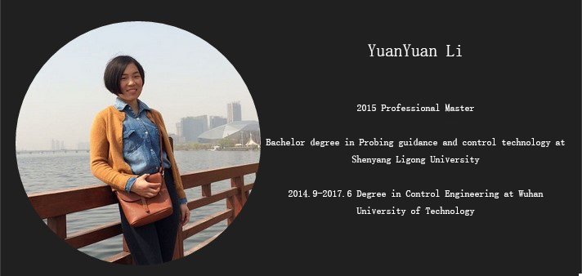
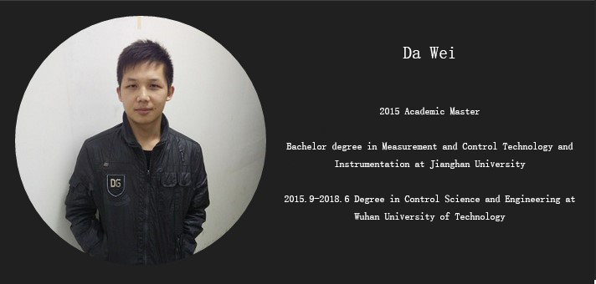
2014:
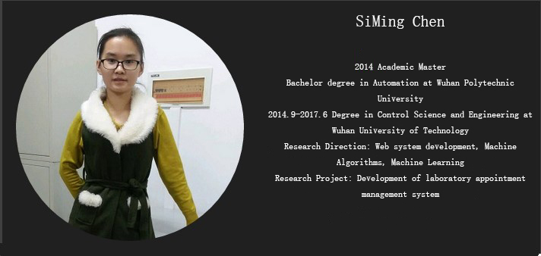
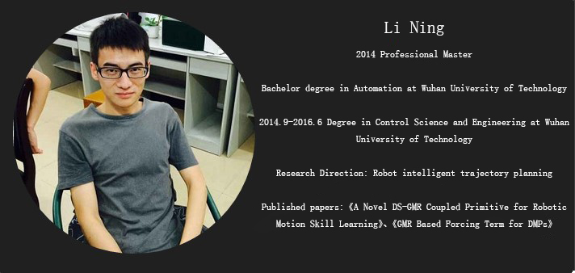
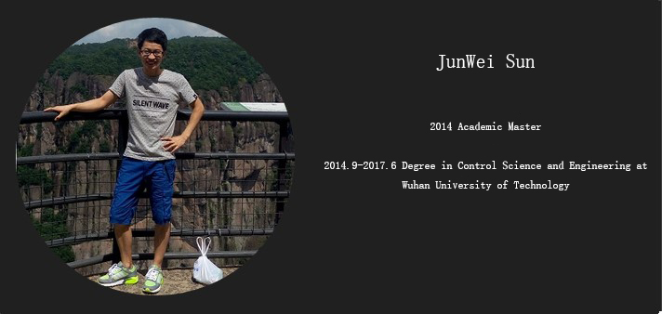
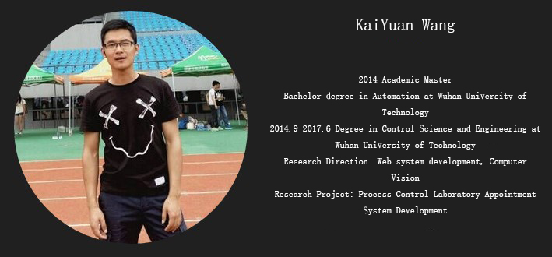
2013:
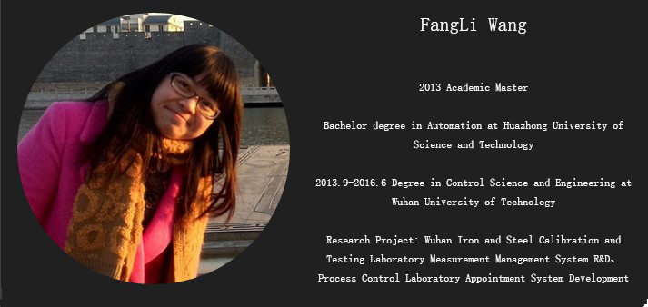
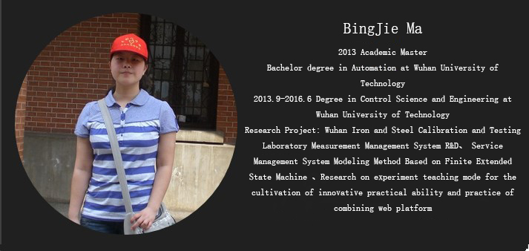
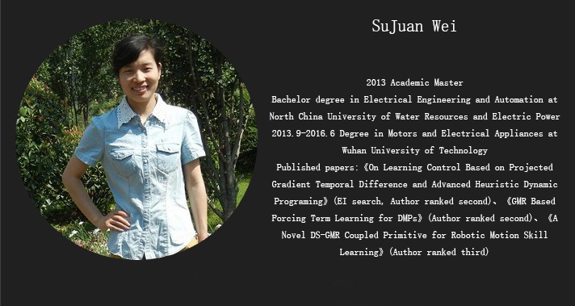
2011:
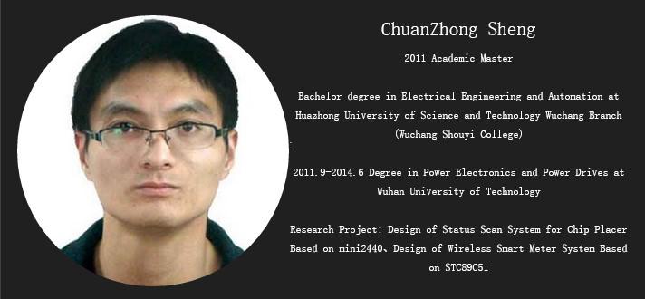
2009:
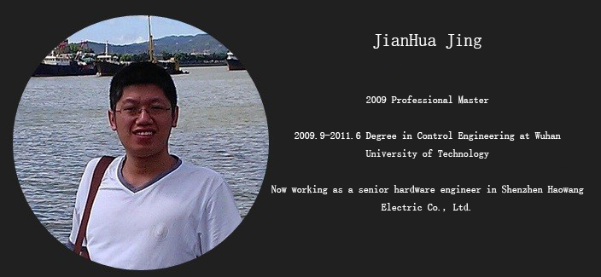
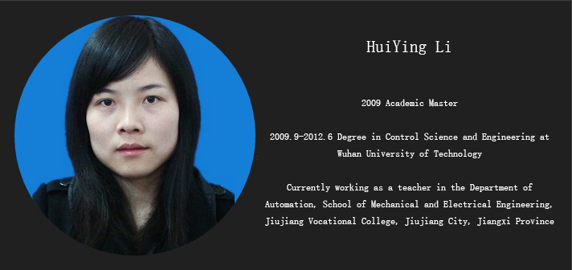
2008:
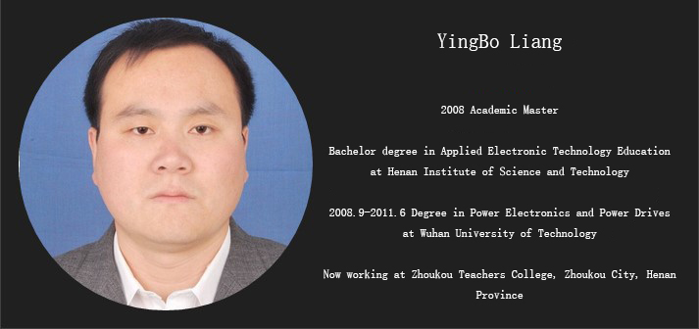
2007:
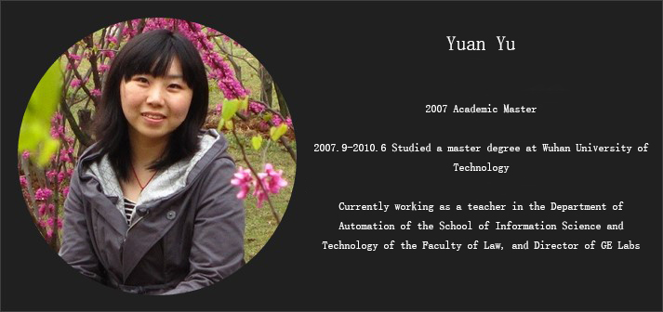
Foreign Master:
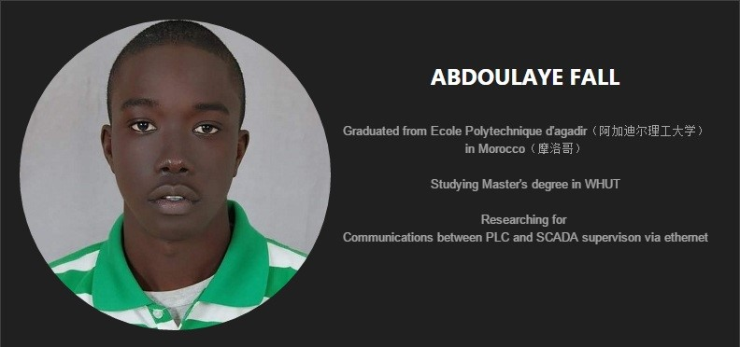

Recent Projects
- theAutomation Laboratory Network Platform.
“Theautomation lab network platform fusing web 2.0 technology and facingcultivation of innovation and practice ability” aims at buildingB/S structure network platform with independent intellectual propertyrights to realize facing the training of undergraduate innovationability in school of automation and standardizing the newexperimental teaching mode. The system uses NGINX as the directionagent server and the volume server, which on server side we deploythe application server to integrate a variety of application service,and at the front end browser we implement the aggregation and displayof static web pages, front-end script and server side service.
Students can access the lab's website system through the campusnetwork. After logging in via the account and password, they canenter the work table, which is responsible for the personal test workand the push of various messages. The system is not in accordancewith the traditions about the conventional module, professional basicexperiment module and comprehensive improvement type and researchinnovation type lab module to set the module and interface, but basedon the user's actual workflow to layout. In the background, we apply“extended finite state machine”(national invention patent201510323287.6) for flow control. The main functions include: testadvanced controlled (preview, examination, appointment anddiscussions, submit), automatic grouping and intra group discussionbased on the timely communication, and community based creativeaggregation and recruitment, appointment and distribution,recruitment and selection, interactive discussion, and etc. Theteachers can also log on to the work table with the account andpassword, which is responsible for personal test work and the push ofvarious messages. The main work of teachers is to complete theinitialization of professional test set (test preparation content,theory test, questionnaire and opening period, the groupingprinciple, etc.), group evaluation, curriculum information uploadingto share, discussing guidance in homework marking, making anappointment to distribution, recruitment and selection, node report,and results publishing, etc.
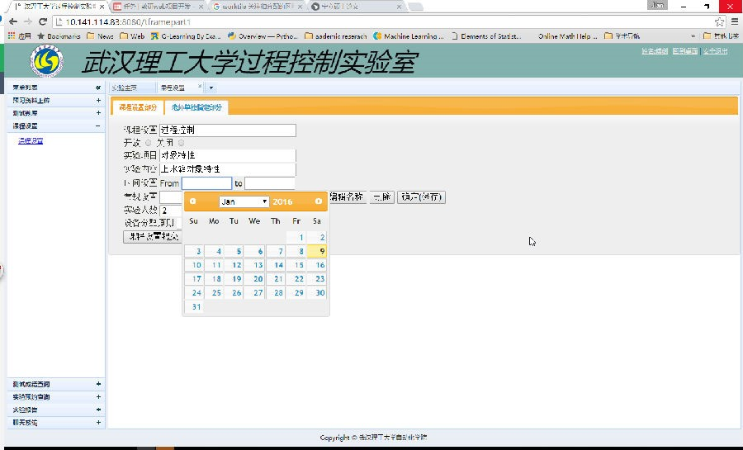
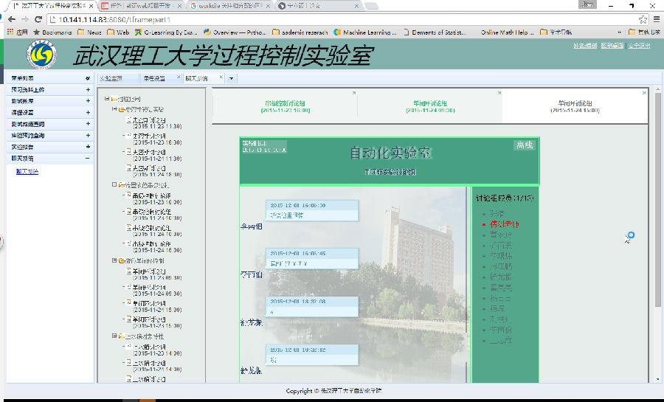
2. Design of flexible production line of circuit board of Wuhan University of Technology.
Flexible production line of circuit board is an intelligent flexible production line to product circuit board, which is developed based on a set of advanced manufacturing concept, the process of production includes intelligent production, processing, assembly, and warehousing, digital logistics tracking and so on. In terms of production management and logistics scheduling software system, combined with the network technology and fieldbus technology, the production process and logistics tracking become efficient and intelligent through the reasonable plan as a whole, optimization algorithm.
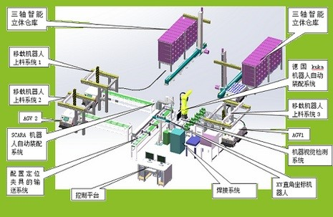
3. Design of WHUT industrial automation comprehensive laboratory
Theindustrial automation comprehensive laboratory designed is customedas meeting the needs of the school of automation teaching tasks,which gives priority for automation class and covers manyprofessional core technology including information, electronics,computer, industrial robots in the field of teaching, scientificresearch and practical needs.
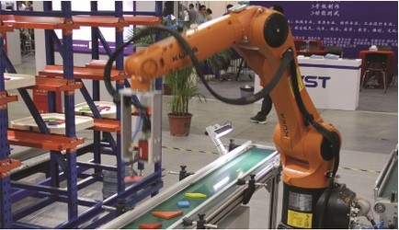

Curriculum Vitae
※Curriculum
(1999)MSc in Master of Computer Application.Huazhong University of Science.
(2006)Phd in Control Theory and ControlEngineering. Universityof Science and Technology Beijing.
(2009-2010)Visiting scholar in Stevens Institute of Technology and University ofRhode Island. Members of IEEE ADPRL TC(Adaptive Dynamic Programmingand Reinforcement Learning Technical Committee). More than 20 papershave been published by SCI and EI in important journals andconferences at home and abroad.

※Teachingsituation
Thecourses in the last five years：
Embedded systemsand Controls；
Sensingand Detection technology；
Adjustthe instrument and Process control system；
Electricaland Programmable Controller；
Industrialcontrol network and Fieldbus；
VisaulBasic；
Scholarshipand Prize：
(2011-2015)Instruct undergraduates to obtain five excellent graduation theses of Hubeiprovince
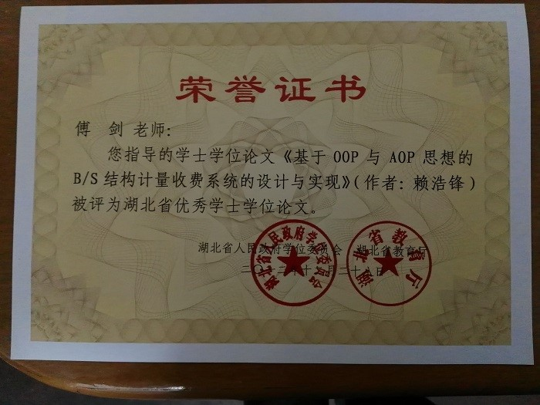
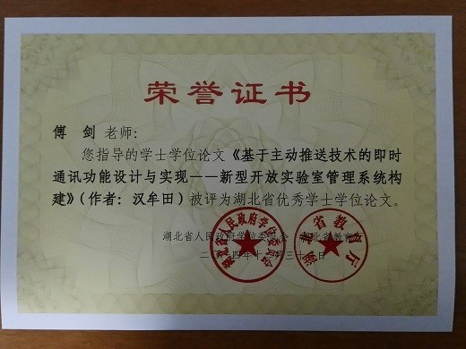

TeachingPractice:
(2015)Leading" smart & green fitness system "participate in the xplore global automation grand and won the“excellent team award” in the global finals in Hanover, Germany.
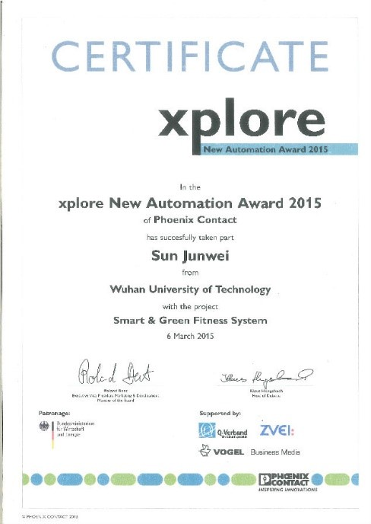
※Scientificresearch
Academicresearch projects
1) Naturalscience foundation in Hubei Province “Approximatedynamic programming based on G2E and autonomous control applicationof mobile robot”
2) Independentinnovation fund in Wuhan University of Technology “Thestudy of several problems in adaptive dynamic programming”
3) Nationalnatural science foundation “Networkcluster multi-attractor coordination switching and multi-target flowassociative research”
4) Americannatural science foundation“CAREER:AIS---An Integrated Optimized and Prediction
Framework forMachine Intelligence Base on Adaptive Dynamic Programming”
5) Enterpriseproject：Researchand development of B/S structural metering management system of Wuhansteel calibration laboratory
6) Enterpriseproject：Theinformation management system and wireless system expansion of thecontainer terminal in Zhanjiang port
7) Enterpriseproject：Developmentof ACG system in hot rolling of Tian Tie Company

Photo
TIME:2017
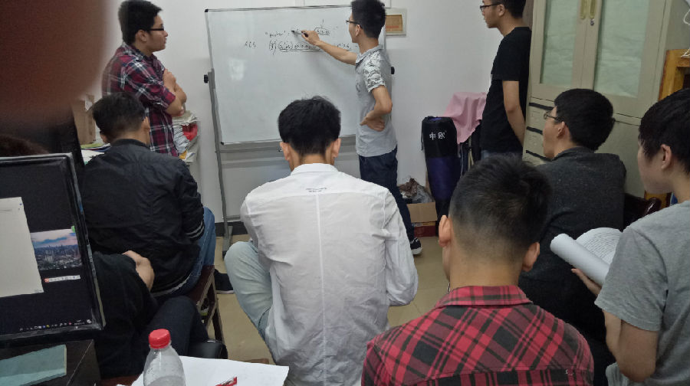
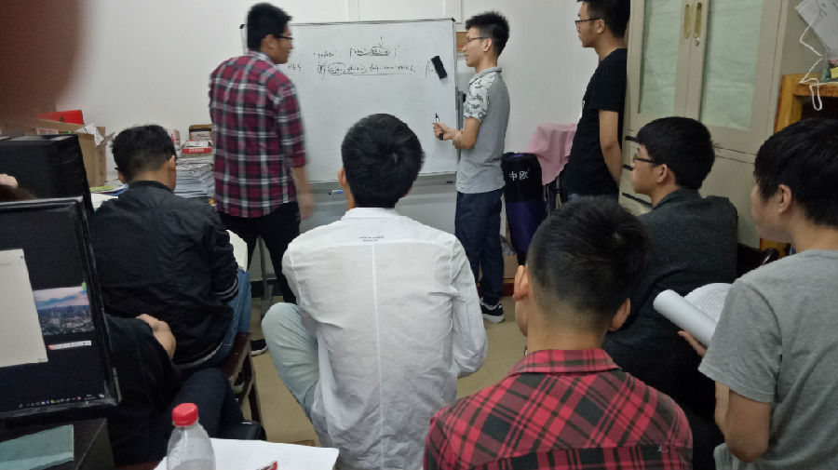

TIME:2016
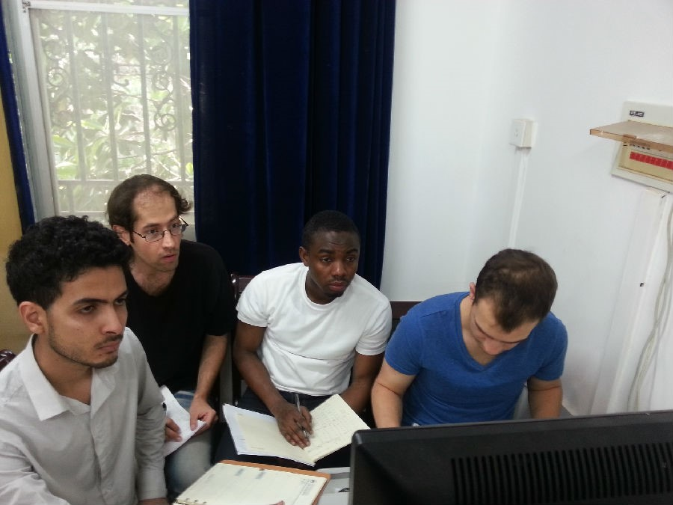
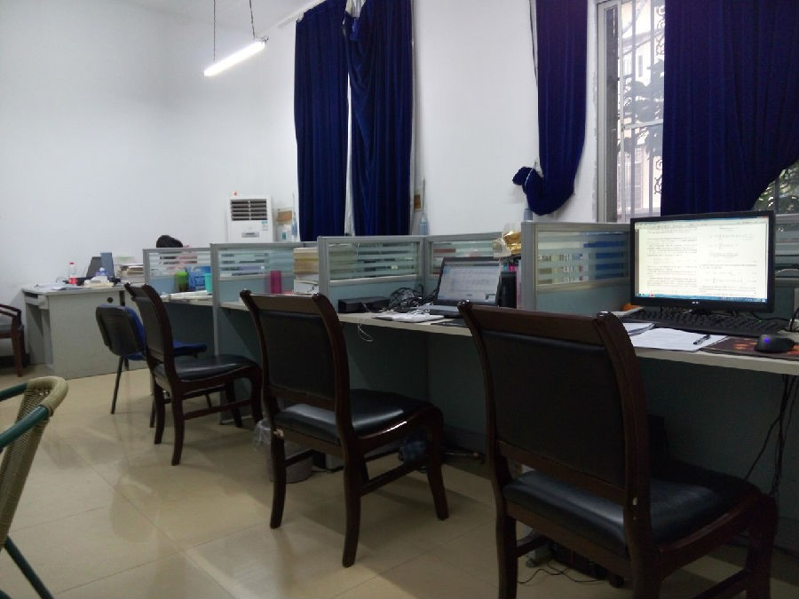
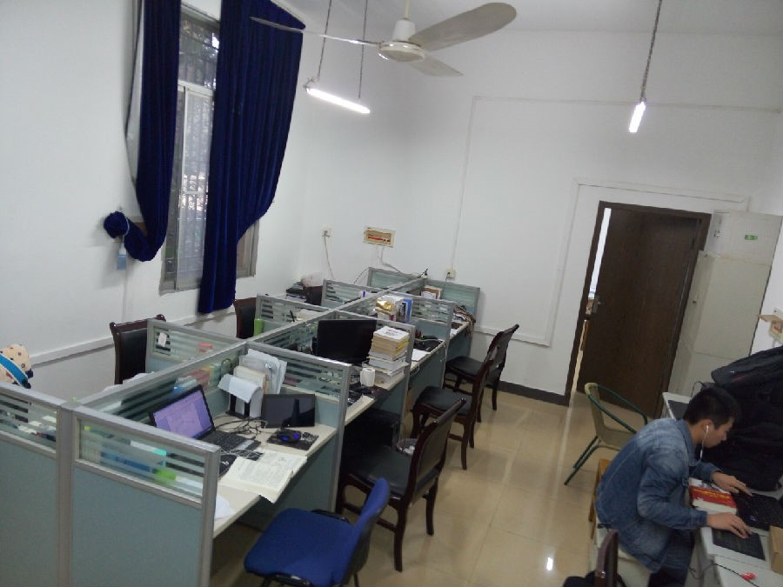

TIME:2015
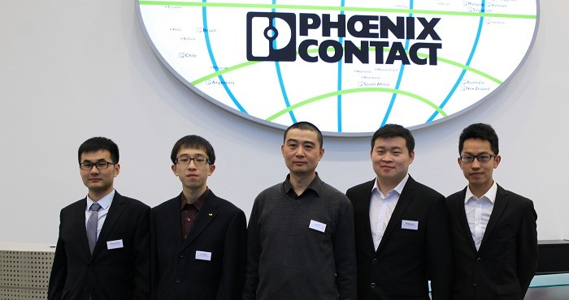
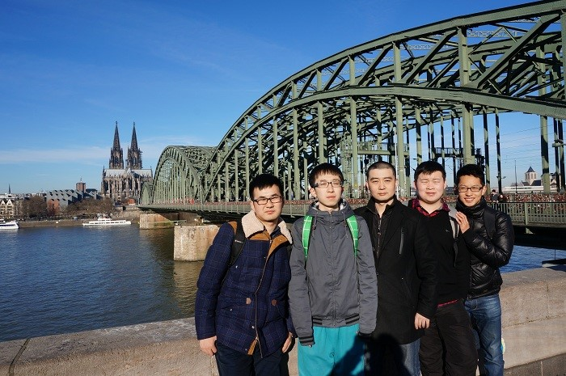
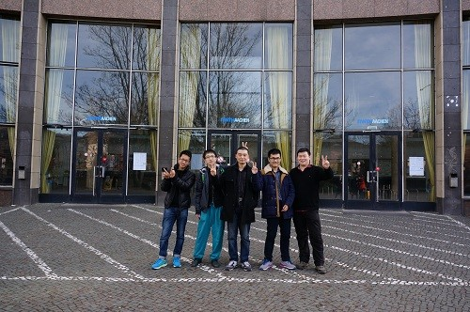
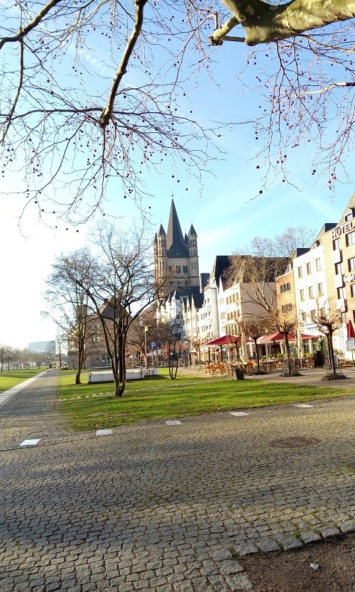
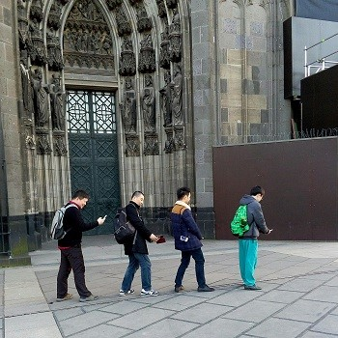
TIME:2015
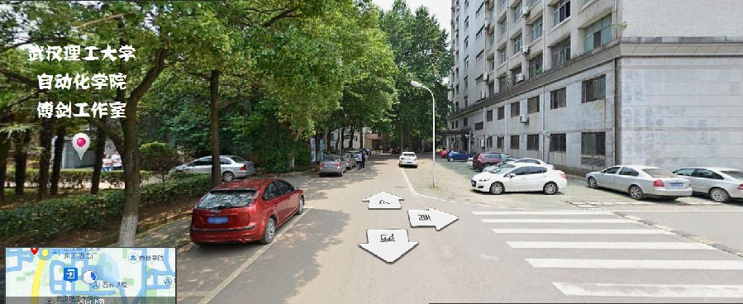
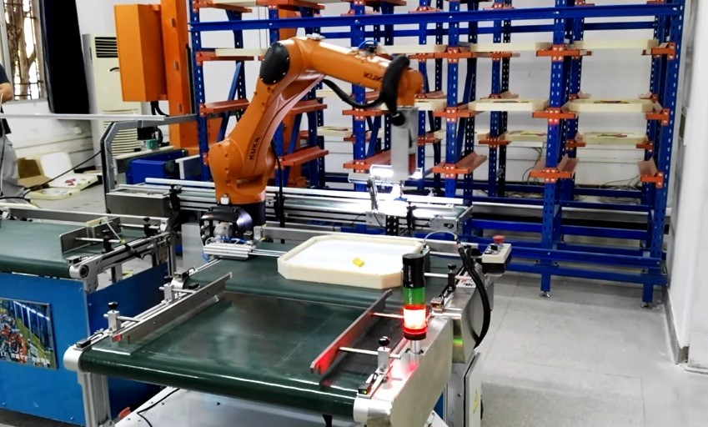
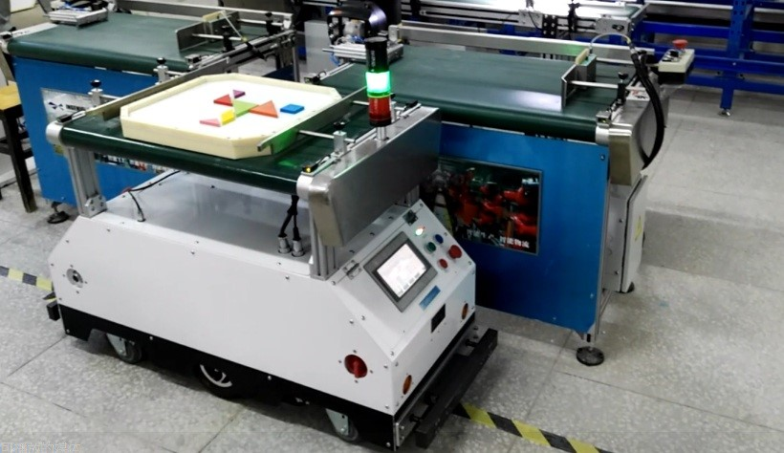

Message Board
You are not logged in, can not give him a message

Contact Information
Email: fujian_whut@163.com
Address: Wuhan University of Technology ,
122 Luoshi Road,Wuhan,Hubei, P.R.China
Postcode: 430070
Updated on:2018-07-20 19:53 Total Visits:288
Scholars
Similar Subject
衣鹏
史大威 Dawei Shi
- 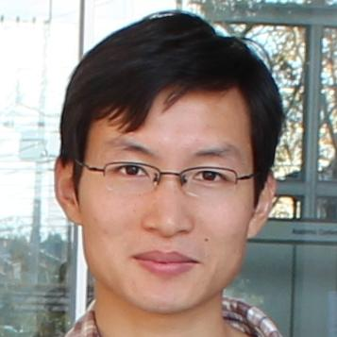
Yang Wu
Xu Chen
郭裕兰
马佳义
Junwei Han （韩军伟）
Pending
- 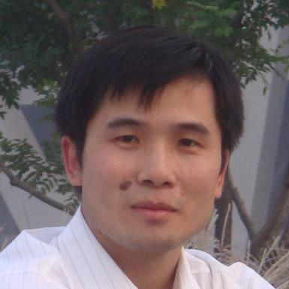
倪伟
王伟
- 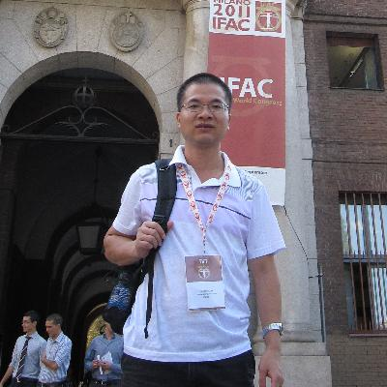
Guo Yuqian
郑萌
- 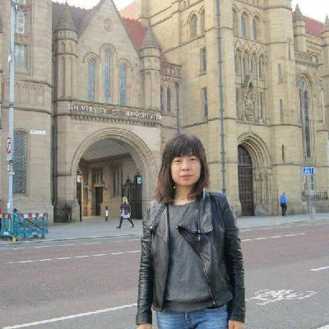
李金娜
赵新超
王映闳
icg.jiawei@gmail.com
陈池来
程龙
范国梁
郑榕
Similar Interests
易海成
- 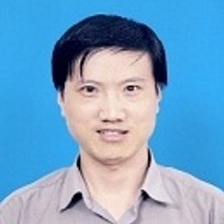
Fanhua Shang (尚凡华)
张建海 Jianhai Zhang
阿尔达克·毛林
桂林
朱明
李冬青
杜长德
- 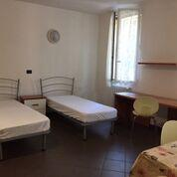
左明成
Yongli Hu （胡永利）
Dong Zhao
Yunlong Liu 刘云龙
Aihua Zheng ( 郑爱华 )
Jianye Hao
Yimin Zhang
- 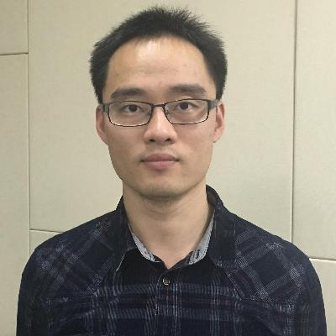
严骏驰
Ebru Akcapinar Sezer
Vipin Dhadwal
Ali Limam
Close

- 团队文档库
- eduroam无线漫游
- 科研主页
- 会议服务平台
- 科信
- 组织通讯录
- 邮箱
- 桌面会议系统
- 用户服务中心
- 官方微博
- 关于我们
Powered by Duckling 3.1 (dHome v1.2.10) （京ICP备09112257号-1 京公网安备11010802017084）
Copyright © 2007-2016 中国科学院计算机网络信息中心 All Rights Reserved

